# Article translation: Vaccination badges

Source: <https://www3.nhk.or.jp/news/easy/k10013273551000/k10013273551000.html>

Sentence translations are in the form: romaji / sentence structure / grammar diagram (if needed) / full translation / interesting features (if any).

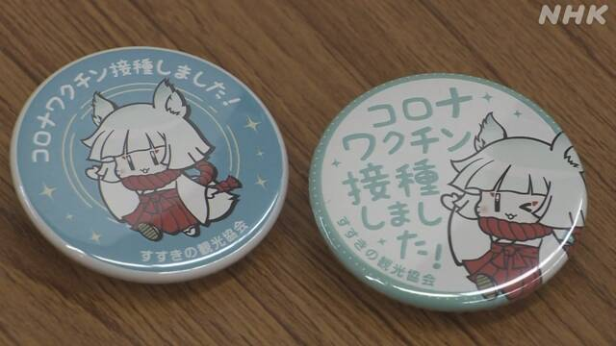

## Article text

**のススキノ　ワクチンがわったにバッジをす**

のススキノには、おをんだりをしたりするがたくさんあります。23、ススキノのがでくなど16000に、２のコロナウイルスの[ワクチン](javascript:void(0))のをめました。

がわったには、「コロナ[ワクチン](javascript:void(0))しました」といた[バッジ](javascript:void(0))をしています。

おをむをするは「とうなので、[ワクチン](javascript:void(0))がだといます。これからどうなるかですが、もらった[バッジ](javascript:void(0))を[つけ](javascript:void(0))たいです」としていました。

のは「[ワクチン](javascript:void(0))のをしたことがわかるようにして、おさんにしてもらいたいです」としていました。

## Header

Sapporo no susukino wakuchin ga owatta hito ni bajji o watasu

[Sapporo (city)] no [Susukino (district)] [vaccine] ga [to end (past indic. plain)] [person] ni [badge] o [to carry (polite)]

In Sapporo city’s Sasakino district, badges have been given to those who have completed a course of vaccination

## Paragraph 1 Sentence 1

Sapporo no susukino ni wa, osake o nondari shokuji o shitari suru mise ga takusan arimasu.

[Sapporo] no [Susukino] ni wa, [sake (liquor)] o [to drink (-tari ending)] [meal] o [to do (-tari ending)] [to do (present indic. polite)] [shop] ga [many] [to exist (inanimate) (present indic. polite)].

In Susukino, there are many shops for drinking sake, having meals, etc.

* [verb]-tari [verb]-tari suru – do [action] and [action]

## Paragraph 1 Sentence 2

23-nichi, susukino no kankoukyoukai ga mise de hataraku hito nado yaku 1 man 6000 hito ni, 2-kaime no shingata koronauirusu no wakuchin no chuusha o hajimemashita.

[23rd], [Susukino] no [tourism board] ga [shop] de [to work] [person] [<etc] [about>] [16,000] [people] ni, [second time] no [new strain] [coronavirus] no [vaccine] no [injection] o [to begin (past indic. polite).

On the 23rd, I HAVE NO IDEA HOW THE HELL TO REARRANGE THIS INTO A COHERENT SENTENCE, about 16,000 people began receiving their second jabs

* ~nado – ~etc
* yaku~ – about~
  + Why is this the one modifier that goes *before* the noun?
* What the hell is up with that comma after the ni?
* Is it written “shingata koronauirusu” rather than “shingata koronauirusu” to avoid operator issues? “kaime no (shingata no koronauirusu) no vaccine etc” when people would naturally read it as “(kaime no shingata) no etc”? (“Second jab against new strain” vs “jab for second new strain”.) Or is it just the usual Japanese yeeting[1] of anything they don’t 100% need?

## Paragraph 2

Chuusha ga owatta hito ni wa, “korona wakuchin sesshu shimashita” to kaita bajji o watashite imasu.

[Injection] ga [to end (past indic. plain)] [person] ni wa, “[corona] [vaccine] [intake] [to do (past indic. polite)]” to [to write (past indic. plain)] [badge] o [to hand over (present prog. polite)].

A badge labelled “I took the corona vaccine” is being given to those who finish their schedule of injections.

## Paragraph 3 Outer Sentence

Osake o nomu mise o keiei suru josei wa “<inner sentences>” to hanashite imashita.

[Sake] o [to drink (present indic. polite)] [shop] o [management] [to do (present indic. polite)] [woman] wa “<>” to [to speak (past prog. polite)].

A manager of a sake bar said “<>”.

## Paragraph 3 Inner Sentence 1

Hito to au shigoto nanode, wakuchin ga hitsuyou dato(?) omoimasu.

[People] to [to meet (present indic. polite)] [work] [because], [vaccine] ga [necessary] WHAT DOES DATO MEAN? IS THAT “[TO BE] [WITH]”? [to think (present indic. polite)]

Because of work meetings with other people, I think the vaccine is necessary

* ~nanode = because ~
  + What’s the distinction with desu kara?

## Paragraph 3 Inner Sentence 2

Kore kara dou naru ka(?) shinpai desu ga, moratta bajji o tsuketai desu.

[This] [from] [in what way] [to become (present indic. plain)] [?] [concern] [to be (present polite)] ga, [to receive (past indic. plain)] [badge] o [to attach (desire/adj.)] [to be (present polite)].

This is a source of concern, but people who have received the badges want to wear them.

* “split infinitive”: dou-ka = somehow, dou-naru-ka = that which will somehow happen
* Need to review the -tai form!

## Paragraph 4

Kankoukyoukai no kaichou wa “wakuchin no chuusha o shita koto ga wakaru youni shite, okyakusan ni anshin shite moraitai desu” to hanashite imashita.

[Tourism board] no [chairman] wa “[vaccine] no [injection] o [to do (past indic. plain)] [thing] ga [to understand (present indic. plain)] [in order to] [to do (connective)], [guest (sonkeigo)] ni [peace of mind] [to do (connective)] [to receive (desire/adj.)] [to be (present polite)]” to [to say (past prog. polite)].

* youni = in order to / in the hope of

1. “To yeet” = “to dispose of at high velocity”